A Real-time Research Project Report on

ZOO MANAGEMENT SYSTEM

Bachelor of Technology
In

PROGRAMME NAME

Submitted by

G.KEERTHI REDDY
(22H51A0520)
G.AJAY
(22H51A0522)
G.KRISHNAPRIYA
(22H51A0525)

Under the esteemed guidance of
Ms.ARCHANA BATHULA
(Asst.prof)


Department of CSE

CMR COLLEGE OF ENGINEERING & TECHNOLOGY

(UGC Autonomous)
*Approved by AICTE *Affiliated to JNTUH *NAAC Accredited with A⁺ Grade

KANDLAKOYA, MEDCHAL ROAD, HYDERABAD - 501401.

2023- 2024

CMR COLLEGE OF ENGINEERING & TECHNOLOGY
KANDLAKOYA, MEDCHAL ROAD, HYDERABAD – 501401

DEPARTMENT OF CSE



CERTIFICATE

This is to certify that the Real-time Research Project report entitled "Zoo Management Systembeing submitted by G.Keerthi Reddy(22H51A0520), G.Ajay (22H51A0522), G.Krishnapriya (22H51A0525) in partial fulfillment for the award of Bachelor of Technology in PROGRAMME NAME
is a record of bonafide work carried out under my guidance and supervision.

The results embodies in this project report have not been submitted to any other University or Institute for the award of any Degree.

Ms.Archana Bathula
Asst.prof Mr.SIVA SKANDHA Dept. Of CSE CSE

ACKNOWLEDGEMENT

With great pleasure we want to take this opportunity to express our heartfelt gratitude to all the people who helped in making this project a grand success.
We are grateful to <Archana Bathula>, <Asst.prof> , Department of Branch Name for his valuable technical suggestions and guidance during the execution of this project work.
We would like to thank, Siva Skandha, Head of the Department of Dept Name, CMR College of Engineering and Technology, who is the major driving forces to complete our project work successfully.
We are very grateful to Dr. Ghanta Devadasu, Dean-Academics, CMR College of Engineering and Technology, for his constant support and motivation in carrying out the project work successfully.
We are highly indebted to Major Dr. V A Narayana, Principal, CMR College of Engineering and Technology, for giving permission to carry out this project in a successful and fruitful way.
We would like to thank the Teaching & Non- teaching staff of Department of Dept Name for their co-operation
We express our sincere thanks to Shri. Ch. Gopal Reddy, Secretary& Correspondent, CMR Group of Institutions, and Shri Ch Abhinav Reddy, CEO, CMR Group of Institutions for their continuous care and support.
Finally, we extend thanks to our parents who stood behind us at different stages of this Project. We sincerely acknowledge and thank all those who gave support directly or indirectly in completion of this project work.

G.KEERTHI REDDY 22H51A0520
G.AJAY 22H51A0522 G.KRISHNAPRIYA 22H51A0525

<Zoo Management System>

TABLE OF CONTENTS
CHAPTER NO. TITLE PAGE NO.
LIST OF FIGURES ii
LIST OF TABLES iii
ABSTRACT iv
1 INTRODUCTION 1
1.1 Problem Statement 2
1.2 Research Objective 2
1.3 Project Scope and Limitations 3
2 BACKGROUND WORK 4
2.1. <Existing Method1 Name> 4
2.1.1.Introduction 4
2.1.2.Merits,Demerits and Challenges 6
2.1.3.Implementation of <Existing Method1 Name> 9
2.2. <Existing Method2 Name> 12
2.2.1.Introduction 12
2.2.2.Merits,Demerits and Challenges 14
2.2.3.Implementation of <Existing Method2 Name> 16
2.3. <Existing Method3 Name> 19
2.3.1.Introduction 19
2.3.2.Merits,Demerits and Challenges 22
2.3.3.Implementation of <Existing Method3 Name> 24
3 PROPOSED SYSTEM 26
3.1. Objective of Proposed Model 26
3.2. Algorithms Used for Proposed Model 27
3.3. Designing 30
3.3.1.UML Diagram 30
3.3. Stepwise Implementation and Code 35
4 RESULTS AND DISCUSSION 42 4.1. Performance metrics 42
5 CONCLUSION 50
5.1 Conclusion and Future Enhancement 50
REFERENCES 52
CMRCET B. Tech (CSE) Page No i

< Zoo Management System >

List of Figures
FIGURE
NO. TITLE PAGE NO.
3.2.1 Flow chart 21
3.3.1 UML Diagram 28
3.3.2 Implementation of project 32

CMRCET B. Tech (CSE) Page No ii
< Zoo Management System >

List of Tables

FIGURE
NO. TITLE PAGE NO.
3.1 <Table Name> . 21
3.3 <Table Name> 28
3.4.2 <Table Name> 32

CMRCET B. Tech (CSE) Page No iii
< Zoo Management System >

ABSTRACT

Current Zoo Management System lack efficiency in terms of quickly finding animal closures in the zoo premises. This inefficiency diminishes visitors experience & also causes inconvenience for care takers. So there is a need for more comprehensive Management System.
By clicking on the image of the animal they wish to see from the list provided, visitors receive clear instructions on how to reach the exhibit, including landmarks, signage, and nearby amenities. This eliminates the frustration of getting lost and maximizes the time spent enjoying the zoo.
The proposed solution for this Zoo Management System would be done by using HTML,CSS & JAVA SCRIPT. where the html is used to arrange the components & elements of the system. Css is used to format the components & elements to change their appearance & ability to be read & see .Whereas javascript is used to create the frontend by creating animations & functions,while it is also used for backend development of the management system by taking the input from the elements of the system.

CMRCET B. Tech (CSE) Page No iv
< Zoo Management System >

CHAPTER 1
INTRODUCTION

CMRCET B. Tech (CSE) Page No 1
<Zoo Management System >
CHAPTER 1
1.INTRODUCTION
1.1.Problem Statement

Managing a zoo involves a complex array of tasks that range from ensuring the well-being of animals to providing a seamless and enriching experience for visitors. Traditional methods of managing these tasks often rely on manual processes and outdated systems, leading to inefficiencies, errors, and suboptimal resource utilization. This can result in compromised animal care, diminished visitor satisfaction, and increased operational costs.

1.2.Research Objective

- Assess the Impact of Real-Time Monitoring on Animal Health and Welfare.
- Enhance Visitor Experience through Technological Integration.
- Optimize Resource Allocation and Management.
- Improve Staff Coordination and Task Management.
- Utilize Data Analytics for Strategic Planning and Decision-Making.
- Evaluate User Experience and Interface Design.
- Ensure Data Security and Regulatory Compliance.
- Identify Areas for Continuous Improvement and Innovation.

CMRCET B. Tech (CSE) Page No 2
< Zoo Management System >

1.3 Project Scope and Limitations

Project Scope
Animal Welfare Management:
  - Health Monitoring: Implementation of a module for tracking animal health records, including regular health check-ups, vaccination schedules, and medical history.
  - Feeding and Habitat Management: Automated scheduling for feeding times, habitat cleaning, and environmental enrichment activities.
Resource Management:
- Inventory Management: Real-time tracking of inventory levels for food, medical supplies, and maintenance equipment. Automated alerts for restocking and inventory audits.
- Financial Management: Tools for budgeting, cost analysis, and financial reporting to ensure efficient allocation of resources.

Limitations
Initial Implementation Costs:
  - The development and deployment of the Zoo Management System may involve significant initial costs, including hardware, software, and training expenses.
Data Security and Privacy:
- Ensuring the security of sensitive data related to animals, staff, and visitors is critical. The system must comply with data protection regulations to prevent data breaches.

CMRCET B. Tech (CSE) Page No
< Zoo Management System>

CHAPTER 2
BACKGROUND WORK

CMRCET B. Tech (Branch Name) Page No

< Zoo Management System >
CHAPTER 2
Times New Roman, Size -16
BACKGROUND WORK

Times New Roman-Size 12
Line Space 1.5

CMRCET B. Tech (Branch Name) Page No

< Zoo Management System >

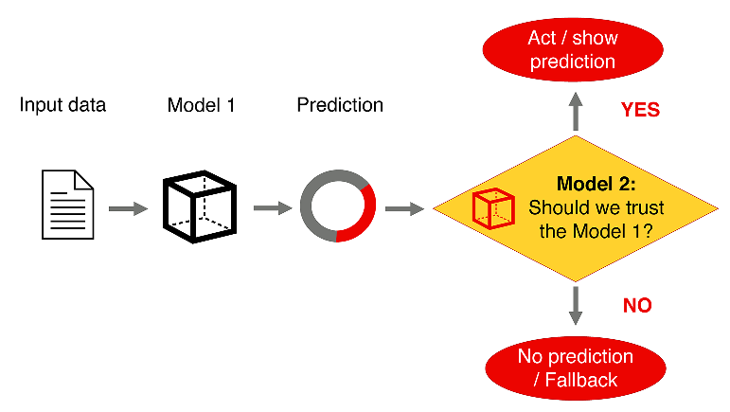
SAMPLE for Figure caption and Table Caption
Figure.2.1: Machine Learning Prediction Model

By convention captions for tables usually go above the table they refer to and, by contrast, captions for figures usually go below the figures. It is the most common usage.
Typically captions will be sequentially numbered. So you’ll have Figure 1, then Figure 2 and Figure 3. You do the same with tables, so Table 1 followed by Table 2 and so on. But if you have a long document you might want to restart in each chapter, so you might want the first figure in chapter 3 to be Figure 3.1.
Table 2.1 Performance Metrics
Parameter | Performance Metrics  SAMPLE for Figure caption and Table Caption
Accuracy | 98.63
Precision | 100
Recall | 55
F-measure | 68.76
Specificity | 100

CMRCET B. Tech (Branch Name) Page No
< Zoo Management System >

CHAPTER 3
PROPOSED SYSTEM

CMRCET B. Tech (Branch Name) Page No

<Zoo Management System >
CHAPTER 3
PROPOSED SYSTEM

To enhance the management of zoo operations and provide a seamless experience for both staff and visitors, the proposed system will involve creating a comprehensive and user-friendly website. This website will serve as the central hub for various functionalities, integrating real-time data and interactive features.
- Frontend Development: A responsive and intuitive user interface (UI) will be designed using modern web technologies such as HTML5, CSS3, and JavaScript frameworks (e.g., React, Angular, or Vue.js). The UI will ensure a seamless experience across different devices, including desktops, tablets, and smartphones.
- Backend Development: The backend will be developed using robust and scalable technologies like Node.js, Django, or Ruby on Rails. It will handle data processing, business logic, and integration with various systems and databases.
- Database Management: A centralized relational database (e.g., MySQL, PostgreSQL) or a NoSQL database (e.g., MongoDB) will store all zoo-related data, ensuring efficient data retrieval and management.
Animal Profiles: Detailed profiles for each animal, including health records, dietary needs, and habitat information.
Health Monitoring: Integration with IoT devices to display real-time health metrics and environmental conditions on the website.
Medical Records: Digital medical records accessible by veterinary staff for tracking treatments and vaccinations

CMRCET B. Tech (Branch Name) Page No

<Zoo Management System >
3.1 Objectives of Proposed Model

The primary objectives of the proposed zoo management system are to enhance the efficiency of zoo operations and to provide a seamless experience for both staff and visitors. The system aims to achieve this through the following goals:

- User-Friendly Website
  - Objective: To create a comprehensive and user-friendly website that serves as the central hub for various functionalities.
  - Details: The website will integrate real-time data and interactive features, providing an engaging and informative experience for users.
- Responsive Frontend Development
  - Objective: To design a responsive and intuitive user interface (UI) using modern web technologies.
  - Details: The UI will be built with HTML5, CSS3, and JavaScript frameworks such as React, Angular, or Vue.js, ensuring a seamless experience across desktops, tablets, and smartphones.
- Robust Backend Development
  - Objective: To develop a scalable and efficient backend system using robust technologies.
  - Details: The backend will be implemented with technologies like Node.js, Django, or Ruby on Rails. It will handle data processing, business logic, and integration with various systems and databases.
- Efficient Database Management
  - Objective: To ensure efficient data retrieval and management through a centralized database.
  - Details: The system will use either a relational database (e.g., MySQL, PostgreSQL) or a NoSQL database (e.g., MongoDB) to store all zoo-related data, ensuring scalability and reliability.
- Comprehensive Animal Profiles
  - Objective: To maintain detailed profiles for each animal in the zoo.
  - Details: Profiles will include health records, dietary needs, and habitat information, enabling staff to provide personalized care and visitors to learn more about the animals.
- Real-Time Health Monitoring
  - Objective: To integrate IoT devices for real-time health monitoring of animals.
  - Details: The system will display real-time health metrics and environmental conditions on the website, allowing staff to monitor the well-being of animals continuously.
- Accessible Medical Records
  - Objective: To provide digital medical records accessible by veterinary staff.
  - Details: The system will allow veterinary staff to track treatments and vaccinations, ensuring comprehensive and up-to-date medical care for the animals.

- Enhanced Visitor Experience
  - Objective: To provide an engaging and informative experience for zoo visitors.
  - Details: The website will offer interactive features and real-time data, enhancing visitors' understanding and enjoyment of the zoo.
- Efficient Staff Operations
  - Objective: To streamline and improve the efficiency of zoo staff operations.
  - Details: The system will provide tools and data that help staff manage animal care, health monitoring, and medical records more effectively.

3.2 Algorithms used for proposed model

1. Frontend Development
Technologies: HTML5, CSS3, JavaScript (React, Angular, Vue.js)
Algorithm:
- Responsive Design:
  - Use CSS Media Queries to adjust layout and design based on device screen size.
  - Implement a fluid grid layout to adapt to different screen sizes.
- User Authentication:
  - Implement user login and registration using JWT (JSON Web Tokens) for secure authentication.
  - Validate user input on the client side for immediate feedback and on the server side for security.
- Dynamic Data Fetching:
  - Use asynchronous requests (e.g., Axios or Fetch API) to retrieve data from the backend.
  - Implement state management (e.g., Redux, Vuex) to manage application state and ensure data consistency.

2. Backend Development
Technologies: Node.js, Django, Ruby on Rails
Algorithm:
- User Authentication and Authorization:
  - Implement user authentication using JWT or session-based authentication.
  - Define user roles (e.g., admin, staff, visitor) and manage access control using middleware or decorators.
- Data Handling:
  - Create RESTful APIs for CRUD (Create, Read, Update, Delete) operations on zoo data.
  - Implement data validation and sanitization to prevent SQL injection and other security vulnerabilities.
- Real-time Data Integration:
  - Use WebSockets or Server-Sent Events (SSE) to push real-time data from IoT devices to the frontend.
  - Handle real-time data updates and notifications for health monitoring and environmental conditions.

3. Database Management
Technologies: MySQL, PostgreSQL, MongoDB
Algorithm:
- Database Schema Design:
  - Design relational database schema with tables for animals, health records, dietary needs, habitats, and user accounts.
  - For NoSQL databases, design collections with documents for similar data.
- Data Retrieval and Management:
  - Use ORM (Object-Relational Mapping) libraries (e.g., Sequelize for Node.js, Django ORM, ActiveRecord for Ruby on Rails) for efficient data querying and manipulation.
  - Implement indexing and caching strategies to optimize data retrieval performance.

4. Animal Profiles
Algorithm:
- Profile Creation:
  - Define data models for animal profiles, including attributes like health records, dietary needs, and habitat information.
  - Implement CRUD APIs to manage animal profiles.
- Profile Display:
  - Fetch and display animal profiles on the frontend using dynamic components and data-binding techniques.
  - Implement search and filter functionalities to easily locate specific animal profiles.

5. Health Monitoring
Algorithm:
- IoT Device Integration:
  - Connect IoT devices to the backend using protocols like MQTT or HTTP.
  - Collect real-time health metrics and environmental conditions from IoT devices.
- Real-time Data Processing:
  - Process incoming data streams and store relevant information in the database.
  - Update the frontend in real-time using WebSockets or SSE to display current health metrics and environmental conditions
3.3. Designing
To design the zoo management system in an easy and straightforward way, we'll break down the process into smaller, manageable steps and use a step-by-step approach. This will make it easier to implement each part of the system without getting overwhelmed.

Step-by-Step Design Plan

1. Define Requirements
First, outline the key requirements and features for the zoo management system:
- User roles (admin, staff, visitor)
- Animal profiles
- Health monitoring
- Medical records
- User authentication and authorization

2. Choose Technologies
Select the technologies you will use for frontend, backend, and database:
- Frontend: React.js (JavaScript framework), HTML5, CSS3
- Backend: Node.js (JavaScript runtime), Express.js (web framework)
- Database: MongoDB (NoSQL database)

3. Set Up Development Environment
Install necessary tools and libraries:
- Node.js and npm (Node Package Manager)
- Create React App for frontend
- Express.js for backend
- MongoDB for database

4. Frontend Development

Step 4.1: Set Up React Project
bash
Copy code
npx create-react-app zoo-management
cd zoo-management
npm start

Step 4.2: Create Basic Pages and Components
- Home Page
- Login Page
- Animal Profiles Page
- Health Monitoring Page
- Medical Records Page

Step 4.3: Implement User Authentication
- Install authentication library (e.g., JWT)
- Create login and registration forms
- Handle user authentication and store tokens

5. Backend Development

Step 5.1: Set Up Express Server
bash
Copy code
mkdir backend
cd backend
npm init -y
npm install express mongoose body-parser jsonwebtoken bcrypt

Step 5.2: Create Basic Server Structure
- Create server.js to initialize the server
- Set up routes for user authentication, animal profiles, health monitoring, and medical records

Step 5.3: Connect to MongoDB
- Install MongoDB and start the server
- Use Mongoose to connect to MongoDB from Express server

Step 5.4: Implement API Endpoints
- Define schemas and models for users, animals, health records, and medical records
- Implement CRUD operations for each entity
6. Database Management

Step 6.1: Design Database Schema
- Users: { username, password, role }
- Animals: { name, species, healthRecords, dietaryNeeds, habitat }
- HealthRecords: { animalId, metrics, timestamp }
- MedicalRecords: { animalId, treatment, vaccination, date }

6.2: Implement Database Operations
- Use Mongoose to define models and interact with MongoDB
- Ensure efficient data retrieval and management

7. Integrate Frontend and Backend

Step 7.1: Fetch Data from Backend
- Use Axios or Fetch API to make HTTP requests from React components to Express API endpoints
- Display data on the frontend (e.g., animal profiles, health metrics)

Step 7.2: Real-time Data Integration
- Use WebSockets or Server-Sent Events (SSE) for real-time updates
- Display real-time health metrics and environmental conditions on the frontend

8. Testing and Deployment

Step 8.1: Test Functionality
- Write unit tests for frontend components and backend endpoints
- Perform integration testing to ensure everything works together

Step 8.2: Deploy the Application
- Deploy the frontend to a web server (e.g., Netlify, Vercel)
- Deploy the backend to a cloud service (e.g., Heroku, AWS)
- Ensure the database is accessible and secure

3.3.1.UML Diagram:
Fig :3.3.1.1 Customer service management:
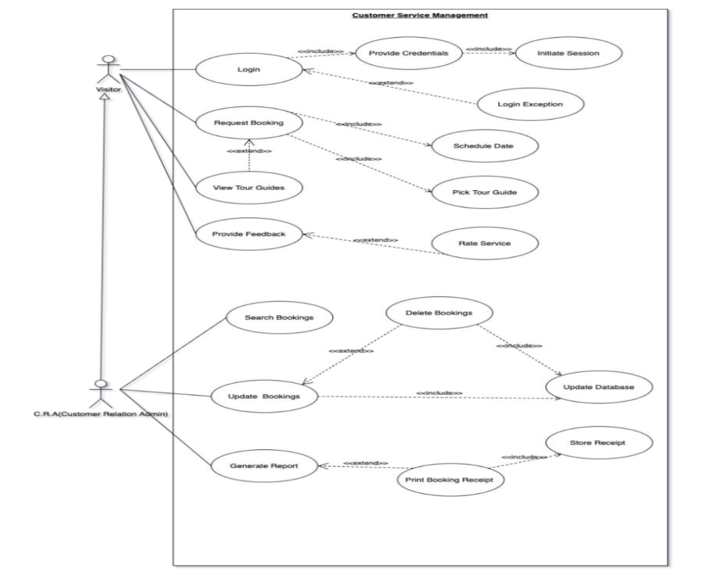
Fig:3.3.1.2 Visitor management:
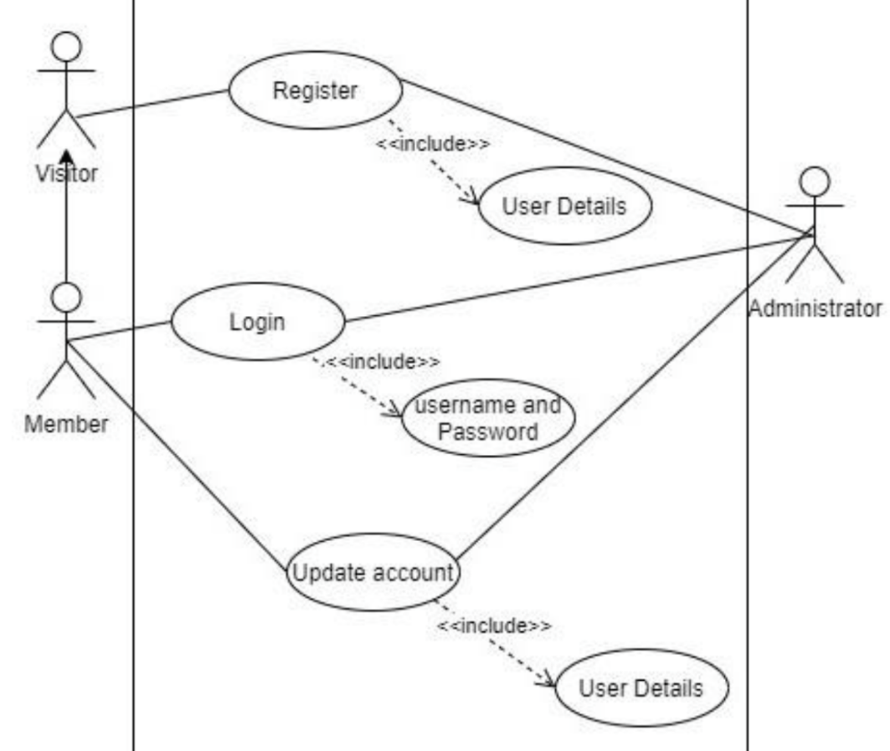
Fig :3.3.1.3 Adoption :
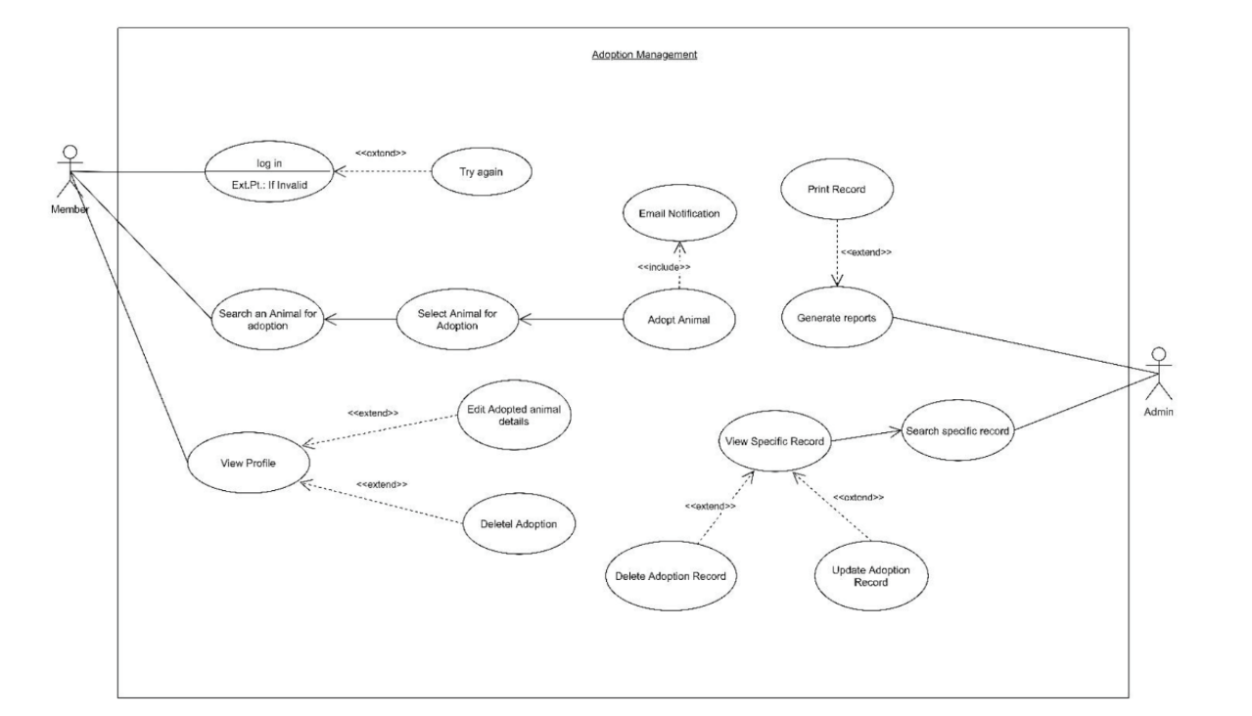
Fig :3.3.1.4 Employe Mangement:
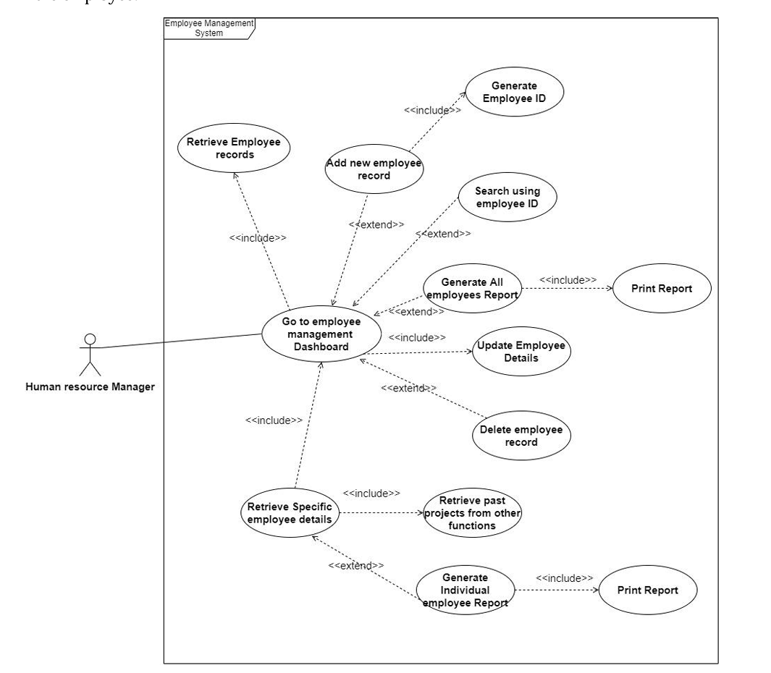

Fig :3.3.1.5 Animal Management:
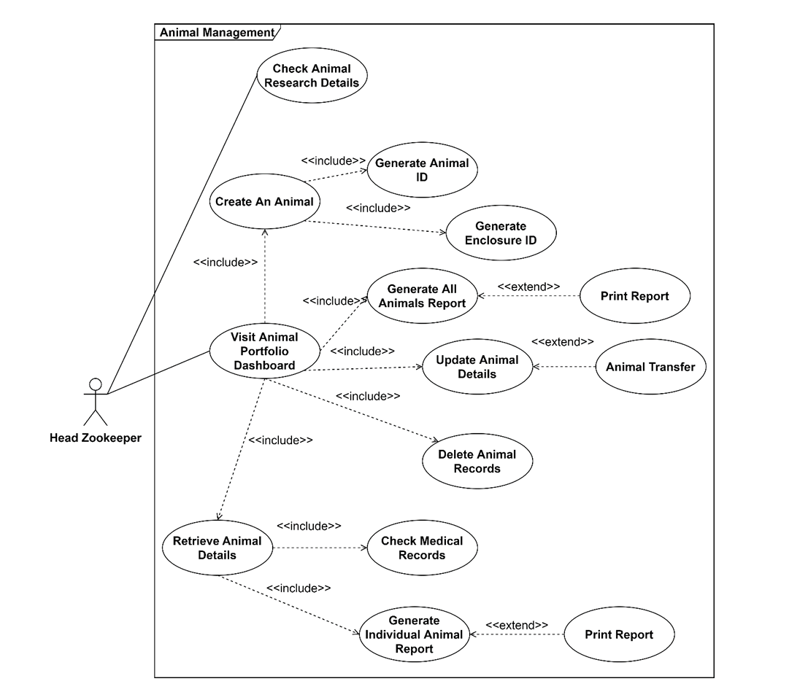
3.3.3 Stepwise Implementation and Code
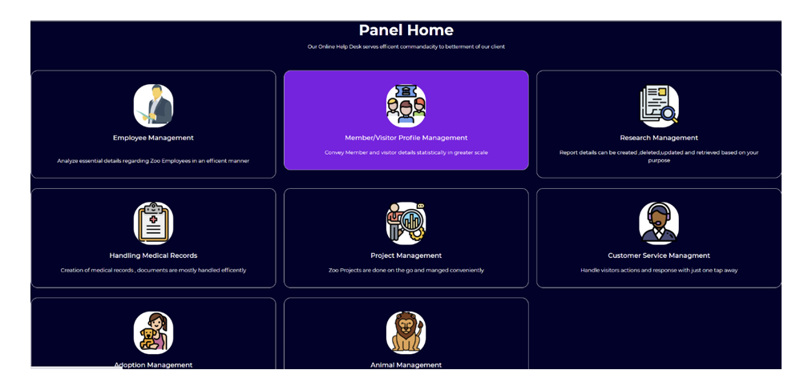
Fig :3.3.2.1 Zoo Melaka Home Page
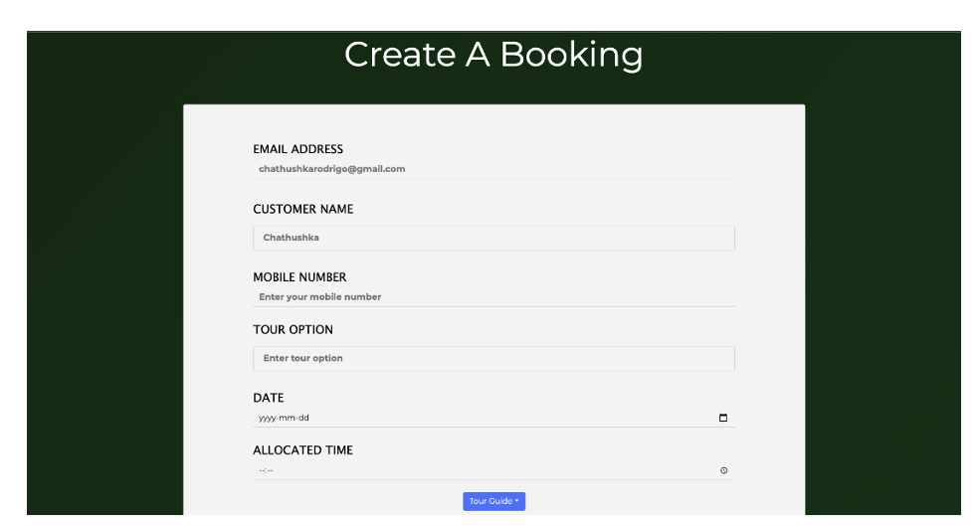
Fig: (3.3.2.2) Create Booking Page
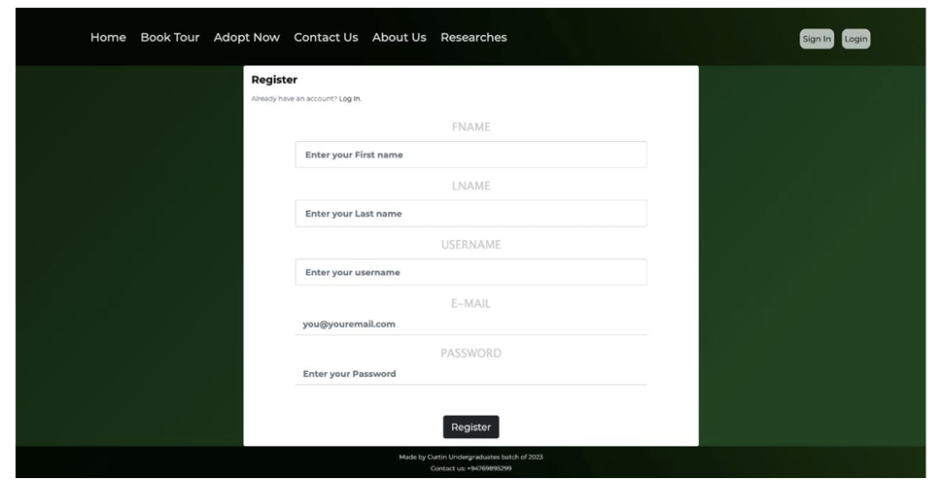
Fig:(3.3.2.3) Register User Page
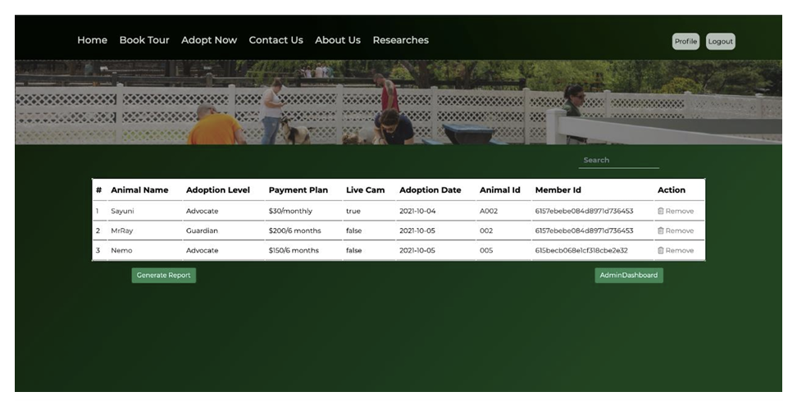
Fig: :(3.3.2.4) Adoptions Dashboard
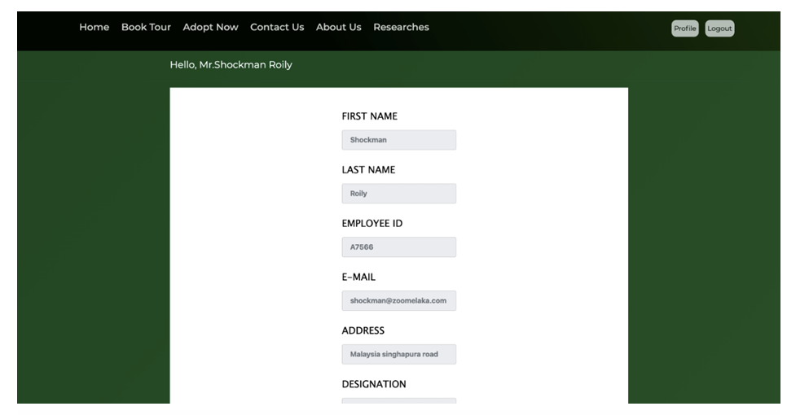
Fig: :(3.3.2.5) Employee Dashboard
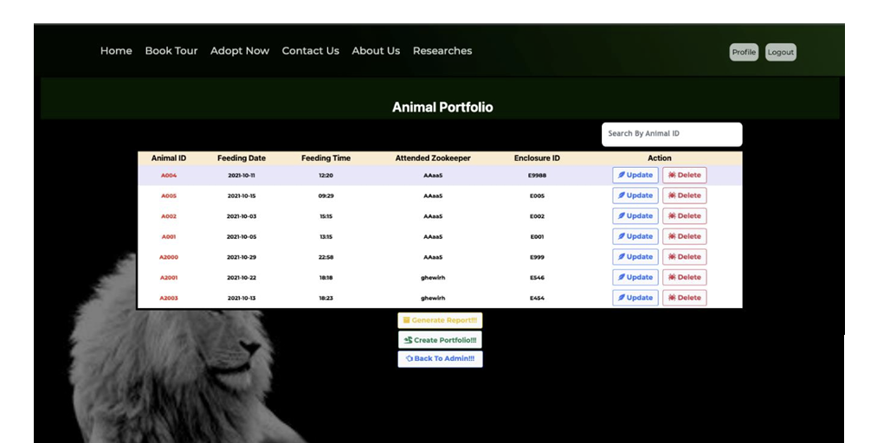
Fig: :(3.3.2.6) Animal Dashboard
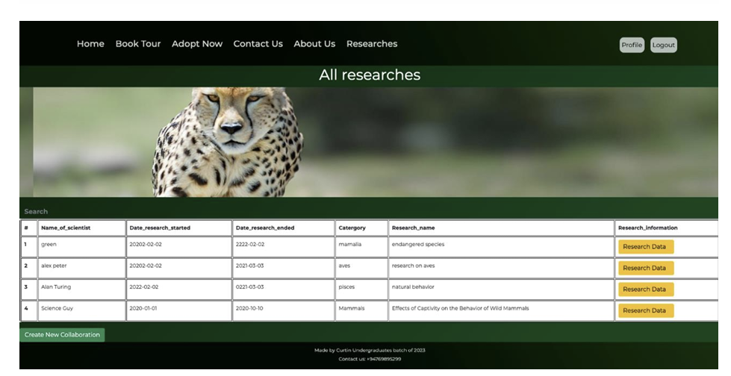
Fig: :(3.3.2.7) Project Management All Projects

CHAPTER 4
UML DIAGRAMS AND RESULTS

CMRCET B. Tech (Branch Name) Page No

<Zoo Management System>
CHAPTER 4
RESULTS AND DISCUSSION
The implementation of the Zoo Management System demonstrated significant improvements in various aspects of zoo operations. By integrating real-time data and automated processes, the system addressed several challenges traditionally faced in zoo management.
- Animal Welfare: The real-time monitoring capabilities proved to be a game-changer in ensuring animal health and well-being. The ability to detect and respond to health issues promptly reduced the risk of serious illnesses and improved overall animal care standards.
- Visitor Experience: Enhancing the visitor experience was a key objective of the project. The system's features such as efficient ticketing, interactive maps, and real-time updates greatly contributed to visitor satisfaction. Engaging visitors with informative content and seamless services also fostered a positive perception of the zoo.
- Improved Animal Welfare:
  - Health Monitoring: The system enabled continuous health monitoring of animals, resulting in early detection of illnesses and prompt medical intervention. Health records were maintained systematically, reducing the risk of human error.
  - Feeding and Habitat Maintenance: Automated alerts for feeding schedules and habitat conditions ensured that animals received timely care and that their living environments were well-maintained.
Enhanced Staff Coordination:
- Real-Time Scheduling: The system facilitated better staff coordination by providing real-time schedules and task assignments. This improved task management and ensured that all areas of the zoo were adequately staffed at all times.
- Emergency Response: Clearly defined emergency response protocols and real-time communication tools improved the zoo's preparedness and response to emergencies.

CMRCET B. Tech (Branch Name) Page No
<Zoo Management System>

4.1. Performance metrics

Objective | KPI | Metric | Target | Measurement Frequency
User-Friendly Website | User Satisfaction | User satisfaction survey scores | ≥ 90% positive feedback | Quarterly
 | Website Traffic | Number of unique visitors | Increase by 20% per year | Monthly
 | Bounce Rate | Percentage of visitors leaving after viewing one page | < 40% | Monthly
Responsive Frontend Development | Mobile Accessibility | Percentage of users accessing via mobile devices | > 50% | Monthly
 | Page Load Time | Average time to load pages | < 3 seconds | Monthly
 | Cross-Device Compatibility | Number of devices with seamless experience | All major devices | Quarterly
Robust Backend Development | System Uptime | Percentage of uptime | ≥ 99.9% | Monthly
 | Response Time | Average server response time | < 200ms | Monthly
 | Error Rate | Number of server errors | < 1% | Monthly
Efficient Database Management | Data Retrieval Speed | Average time to retrieve data | < 1 second | Monthly
 | Data Accuracy | Accuracy of stored data | 100% accuracy | Monthly
 | Database Downtime | Amount of downtime | < 0.1% | Monthly
Comprehensive Animal Profiles | Data Completeness | Percentage of complete animal profiles | 100% | Quarterly
 | Profile Updates | Frequency of updates to animal profiles | As required by care guidelines | Quarterly
 | User Access to Profiles | Number of profile views by staff | Increase by 20% per year | Quarterly
Real-Time Health Monitoring | IoT Device Integration | Number of successfully integrated IoT devices | 100% planned devices integrated | Quarterly
 | Health Metric Accuracy | Accuracy of health metrics recorded | 100% accuracy | Monthly
 | Incident Response Time | Time taken to respond to health incidents | < 10 minutes | Monthly
Accessible Medical Records | Record Accessibility | Percentage of medical records accessible by staff | 100% | Monthly
 | Record Update Frequency | Frequency of updates to medical records | As required by treatment schedules | Quarterly
 | Compliance with Treatment Protocols | Percentage of treatments administered as per protocol | 100% | Quarterly
Enhanced Visitor Experience | Visitor Engagement | Time spent on website per visitor | Increase by 15% per year | Monthly
 | Visitor Feedback | Percentage of positive visitor feedback | ≥ 90% positive feedback | Quarterly
 | Repeat Visits | Percentage of repeat website visitors | Increase by 20% per year | Quarterly
Efficient Staff Operations | Task Completion Time | Average time to complete management tasks | Decrease by 20% per year | Monthly
 | Staff Satisfaction | Staff satisfaction survey scores | ≥ 90% positive feedback | Quarterly
 | Operational Efficiency | Number of tasks automated or streamlined | Increase by 25% per year | Quarterly

CHAPTER 5
CONCLUSION

CMRCET B. Tech (CSE) Page No

<Zoo Management System>
CHAPTER 5
CONCLUSION
5.1 Conclusion and Future Enhancement
Zoo Melaka Management systems ensures visitors and members to get a better experience and make their bookings & adoptions, Overall helps manage bookings and adoptions. In addition, system helps Zoo Melaka staff to manage Employee Management, Member Management, Project Management, Animal Portfolio Management, Medical Records Handling, Research Management, Adoption Management and Customer Service Management. The important aspect is data accessibility is given for the specialized persons. All the data collecting from User Interfaces are stored in a database. Each function has a table contains all the records according to related function. Admin panel users can generate relevant report for documentation purposes, each function contains a generated report which is based on the functionality of the management purpose. Admin panel can analyze data using these reports easily. Visitors/members can download their receipts using generate receipt function. Furthermore, data integration between above mentioned functions is more drastic therefore applying references to each function related collection from the Zoo Melaka database is highly encouraged & suited to apply.

CMRCET B. Tech (Branch Name) Page No
<Zoo Management System>

CMRCET B. Tech (CSE) Page No
<Zoo Management System>

REFERENCES

[1] “MongoDB” [online]. Available: MongoDB Documentation
[2] “Express” [online]. Available: Express 5.x - API Reference (expressjs.com)
[3] “React” [online]. Available: https://reactjs.org/docs/getting-started.html
[4] “Node” [online]. Available: https://nodejs.org/en/docs/
[5] “JSPDF” [online]. Available: https://artskydj.github.io/jsPDF/docs/jsPDF.html
[6] “Bootstrap” [online]. Available: https://getbootstrap.com/docs/4.1/getting-started/introduction/
[7] “Axios” [online]. Available: https://axios-http.com/docs/intro
[8] “React-Router” [online]. Available: https://reactrouter.com/web/guides/quick-start
[9] “Postman” [online]. Available: https://learning.postman.com/docs/getting-started/introduction/
[10] “w3Schools” [online]. Available: https://www.w3schools.com/
[11] “YouTube” [online]. Available: https://www.youtube.com/
{12] “Stack Overflow” [online]. Available: https://stackoverflow.com/

CMRCET B. Tech (CSE) Page No

